Ex. No: 03
Date: 01/05/2026
Network Security Essentials
Experiment No. | 03
Experiment Title | Network Security Essentials
Platform | TryHackMe
Hours Required | 2
TryHackMe Link | https://tryhackme.com/room/networksecurityessentials

AIM
To explore fundamental concepts of network security including passive and active reconnaissance, network protocols, Nmap scanning techniques, and understanding of common network services and their vulnerabilities.
The networks are the backbone of every modern organization. Servers, workstations, applications, and security devices don’t exist in isolation; they are interconnected, forming a single ecosystem**. T**his room will introduce us to the fundamental concepts of network security from a defensive perspective. While our focus will be on the logs and data sources we encounter daily, we’ll start by building a strong understanding of how networks are structured, why they are essential to protect, and why monitoring the perimeter is critical for early detection of attacks.

TOPICS COVERED
- Introduction to Network Security
- Passive Reconnaissance (WHOIS, nslookup, dig)
- Active Reconnaissance (ping, traceroute, Telnet, Netcat)
- Nmap Live Host Discovery
- Nmap Basic Port Scans
- Nmap Advanced Port Scans
- Nmap Post Port Scans
- Protocols and Servers
- Protocols and Servers 2
- Net Sec Challenge
THEORY
Introduction to Network Security
Network Security focuses on protecting the usability, integrity, and safety of network infrastructure. The goal is to allow legitimate users access while preventing unauthorized access.
Network security involves both hardware and software technologies. Effective network security targets a variety of threats and stops them from entering or spreading on your network.
Passive Reconnaissance
Passive reconnaissance involves gathering information about a target without directly interacting with it.
Key tools:
• WHOIS: Queries domain registration info
• nslookup: Queries DNS records for a domain
• dig: DNS lookup utility providing detailed answers
• DNSDumpster: Online tool for DNS recon
• Shodan.io: Search engine for internet-connected devices
Active Reconnaissance
Active reconnaissance involves directly interacting with the target to gather information.
Key tools:
• ping: Tests connectivity and measures round-trip time
• traceroute: Shows the path packets take to a target
• Telnet: Tests connection to specific ports
• Netcat (nc): Versatile networking utility for reading/writing network connections
Nmap Scanning
Nmap (Network Mapper) is a powerful open-source network scanning tool.
Common scan types:
• -sn (Ping Scan): Discover live hosts
• -sS (SYN Scan): Stealthy half-open scan
• -sT (TCP Connect): Full TCP connection
• -sU (UDP Scan): Scans UDP ports
• -sV (Version Detection): Detects service versions
• -O (OS Detection): Identifies operating systems
• -A (Aggressive): Enables OS detection, version detection, script scanning, and traceroute

TASK 2: Lab Connection
TASK 3: A Network — Overview
To understand network security, it is essential to comprehend what a network is, the components or assets that form it, and how these components work together.
Use the link and read the rest of the information. no answer needed
TASK 4: Network Visibility
Continue to read to understand
No answer needed
TASK 5: Network Perimeter
Continue to read to understand
No answer needed

TASK 6: Network Perimeters: Monitoring and Protecting
Monitoring the perimeter involves utilizing firewalls, intrusion detection/prevention systems (IDS/IPS), and access control to examine and limit exposure, while enforcing security rules. We will have to do the reading to effective answer the questions.
Q1: Examine the firewall logs. Which IP address is performing the port scan?
When we open the file, we see a series of TCP blocks attempted from an IP of 203.0.113.10. This indicates that an attacker is testing our network to determine which ports are open or closed, while the firewall is performing its job and blocking them.
Ans: 203.0.113.10
Q2: In the WAF Logs, which single source IP is responsible for all the blocked web attacks?
Ans: 198.51.100.12
Q3: In the VPN logs, how many brute-force attempts failed?
From the logs, we can see that an attacker is attempting to guess a user’s password to gain remote access to the network, which generates a significant amount of noise in the authentication logs.
which will create a lot of failed_auth attempts. Since it is a log file, a .txt, I searched only for words that say FAILED_AUTH and then counted how many there are.
Ans: 90
Q4: Which suspicious IP address was found attempting the brute-force attack against the VPN gateway?
Still from the same log file, we can see that all the failed_auth came from a certain IP with no user; every instance goes to an internal IP with different usernames at different instances.
Ans: 45.137.22.13
TASK 7: Perimeter Logs: Investigating the Breach
Q1: Examine the firewall logs. What external IP performed the most reconnaissance?
This is simply a matter of finding the IP address with the most scans. I used the manual method with the command line. I then navigated to the directory where the logs were located. In this question, we will be looking for the IP with the most block requests. We first analyze the firewall logs for any block requests using the command cat firewall.log | grep “BLOCK” | head to read just the top of the log file, and the blocked requests indicate that an external IP has been found probing against internal IPs using various ports (22,23,21,445,4444). To then understand which IP is responsible for the maximum BLOCK requests. We ran the command cat firewall.log | grep “BLOCK” | cut -d’ ‘ -f5 | cut -d: -f1 | sort -nr | uniq -c
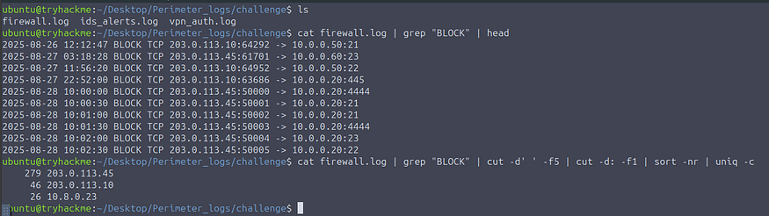
Ans: 203.0.113.45
Get TcyberSec007’s stories in your inbox
Join Medium for free to get updates from this writer.
Subscribe
Remember me for faster sign in
Q2: In the firewall log, Which internal host was targeted by scans?
And: 10.0.0.20
Q3: Which username was targeted in VPN logs?
We first examine the number of failed attempts, using the following command cat vpn_auth.log | grep FAIL | cut -d’ ‘ -f3 | sort -nr | uniq -c, We can clearly see that the suspicious IP from the above question has multiple failed VPN login attempts. Let’s now use the following command cat vpn_auth.log | grep 203.0.113.45 to narrow down on the suspicious IP, we then see multiple login attempt was made against a certain user svc_backup which resulted into failed and eventually down the line was successful.
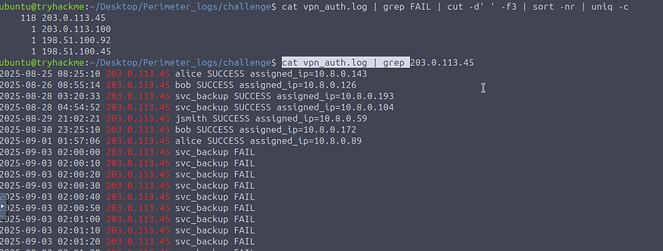
Ans: svc_backup
Q4: What internal IP was assigned after successful VPN login?
Scrolling down from the same output above, we can see a successful login and an assigned IP.

Ans 10.8.0.23
Q5: Which port was used for lateral SMB attempts?
By now, we have confirmed that the attacker has successfully gained initial access and obtained an internal IP address. Let’s filter through the firewall logs and see if we can find the footprints of any lateral movement from the compromised host IP of 203.0.113.45 using the command cat firewall.log | grep “203.0.113.45” | grep “ALLOW” | head
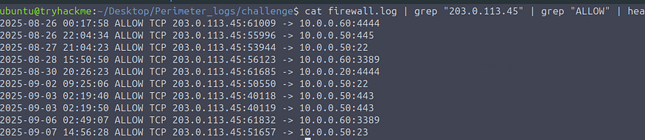
From the output, we can observe that the compromised IP is probing internal machines 10.0.0.20, 10.0.0.51, 10.0.0.60 on various ports on three main ports SMB/RDP/SSH (445/3389/22)
Ans: 445
Q6: In the IDS logs, which host beaconed to the C2?
Examining the IDS alerts reveals a specific alert related to C2 Beaconing, indicating potential C2 communication. We use the command cat ids_alerts.log | grep C2 | head
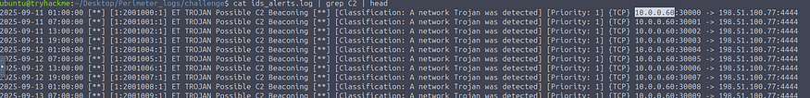
The output clearly confirms our suspicion about one of the internally compromised hosts.
Ans: 10.0.0.60
Q7: During the investigation, which IP was observed to be associated with C2?
We will then filter against the compromised IP responsible for C2 beaconing, using the command cat ids_alerts.log | grep -n “10.0.0.60” | cut -d’ ‘ -f6,7,8,9,10,19,22,23 | head -n 15
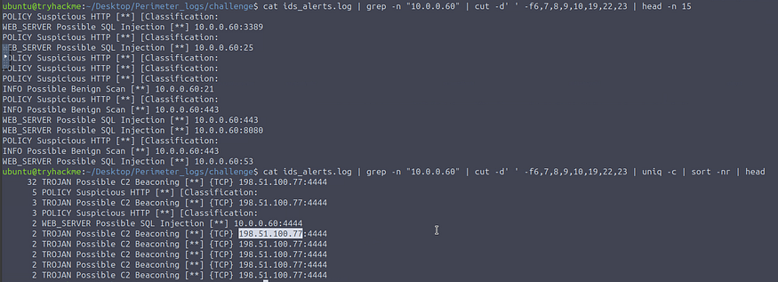
The output further confirms that the infected host is engaging in suspicious activities. We can use the following command: cat ids_alerts.log | grep -n “10.0.0.60” | cut -d’ ‘ -f6,7,8,9,10,19,22,23 | uniq -c | sort -nr | head to show the stats of the alerts triggered against the infected host.
Ans: 198.51.100.77
Q8: Which host showed the exfiltration attempts?
Now that we have identified the C2 communication and examined other alerts against suspicious IPs, let’s investigate if there are any indicators of data being exfiltrated from our network. We will apply a filter on the compromised hosts and examine the traffic originating from those to an external destination IP. We use the command cat firewall.log | grep “198.51.100.77” | cut -d’ ‘ -f5,6,7 | uniq | sort.
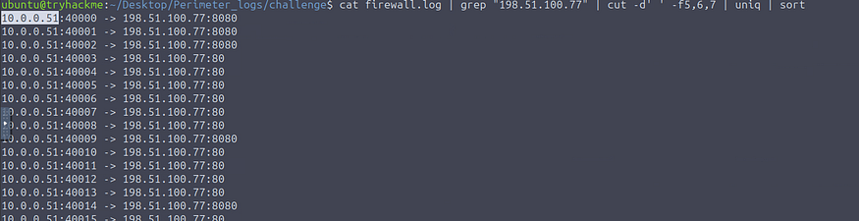
The output clearly indicates that the compromised host IP is sending a substantial amount of traffic to an external IP address.
Ans: 10.0.0.51
TASK 8: Conclusion
NO ANSWERS NEEDED

RESULT
Successfully explored network security concepts including passive reconnaissance using WHOIS/nslookup/dig, active reconnaissance with ping/traceroute, and various Nmap scanning techniques to discover hosts, open ports, and service versions

